Project Initialization and Planning Phase

|  |  |
| --- | --- |
| Date | 15 March 2024 |
| Team ID | xxxxxx |
| Project Name | Human Resource Management: Predicting  Employee Promotions Using Machine Learning |
| Maximum Marks | 3 Marks |

Define Problem Statements (Customer Problem Statement Template):

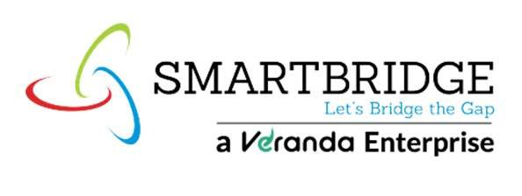In the dynamic landscape of human resource management, companies face considerable hurdles in ensuring fair and efficient employee promotion processes. Organizations grapple with large volumes of data, potential biases, and the necessity for transparent decision-making. Large enterprises encounter difficulties in consistently recognizing top talent, startups strive for equitable promotion systems to stimulate growth, and businesses in competitive sectors seek to retain their most valuable employees. To address these challenges, we propose creating a machine learning model that predicts employee promotions based on key indicators such as performance metrics, tenure, skills, and feedback. This solution aims to optimize promotion workflows, guarantee fairness, improve employee retention, and cultivate a culture of meritocracy and professional development, thereby driving organizational success and enhancing employee satisfaction.

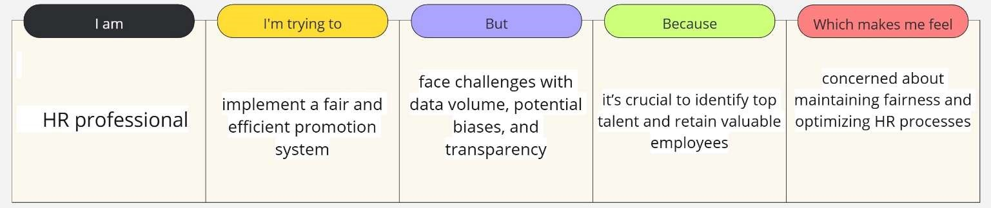

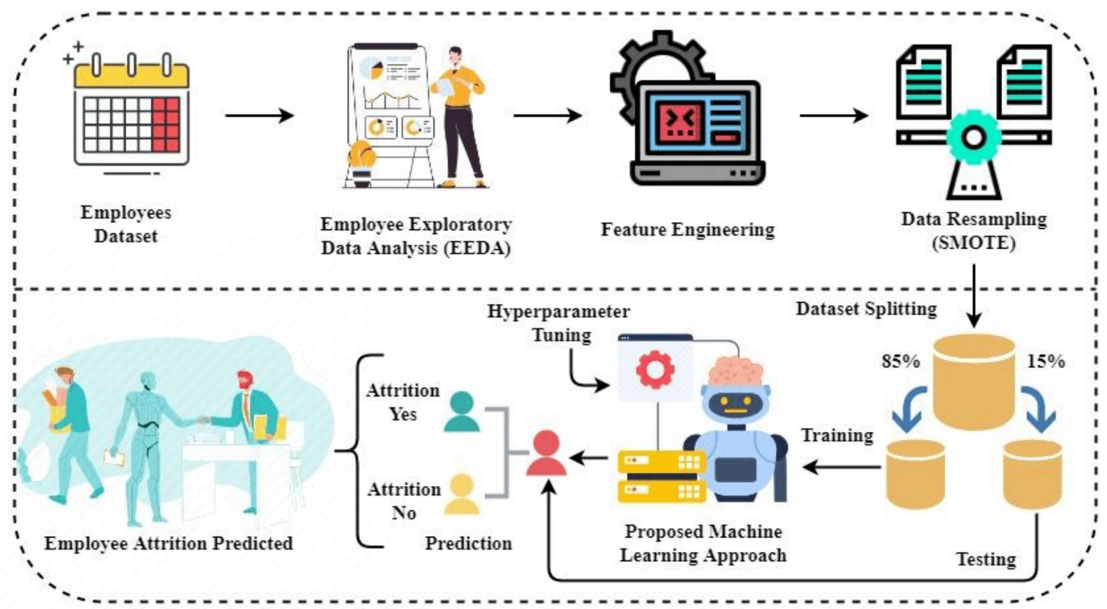

|  |  |  |  |  |  |
| --- | --- | --- | --- | --- | --- |
| Problem  Statement  (PS) | I am (Customer) | I’m trying to | But | Because | Which makes me feel |
| PS-1 | An HR  professional | implement a fair and efficient promotion system | face challenges with data volume, potential biases, and transparency | it’s crucial to identify top talent and retain valuable employees | concerned about maintaining fairness and optimizing HR processes |